SolisCloud User Guide
Part 1: Getting Started – Registration, Migration, and Logging in [pages 1 to 3]
Part 2: Monitoring and Alarms [pages 4 and 5]
Part 3: Commissioning – Creating Plants and Adding Dataloggers [pages 6 to 7]
Part 4: Organization Management – Adding new users and guests [pages 8 to 12]

Part 1: Getting Started – Registration, Migration, and Logging in
Open a browser and go to www.soliscloud.com (Chrome, Safari, Edge, and Firefox work the best)
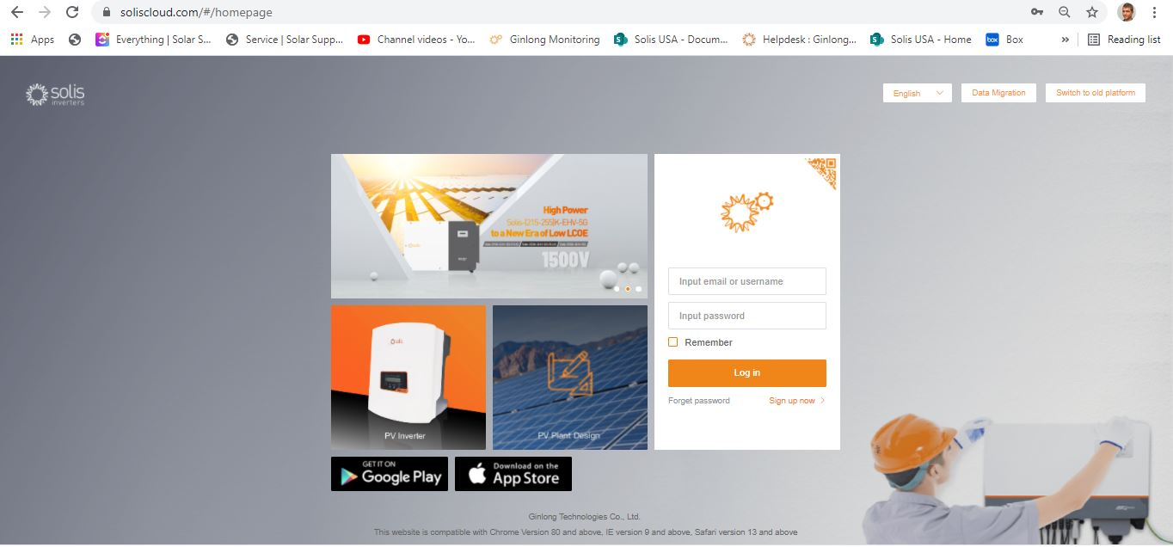
New users will need to register and existing users will need to migrate their systems over to the new platform
Registration: If you are a new user, click on “Sign up now” and then click “Registered Organization” if you are an installer or technician. Click “Registered Owner” if you are a system/plant owner
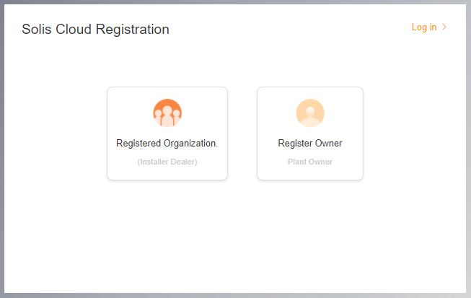
Registering an Organization: Enter in the organization name and administrator’s email address. Click on “Verification code” to have a code sent to the email address entered. Then type in that code in the box called “Vcode” where it says to “Input verification code”. Enter in a username and password. The “Organization Code” will auto-generate. Click “Another” if you want a different organization code. Check the box by “I have read and agree” then click “Register”.
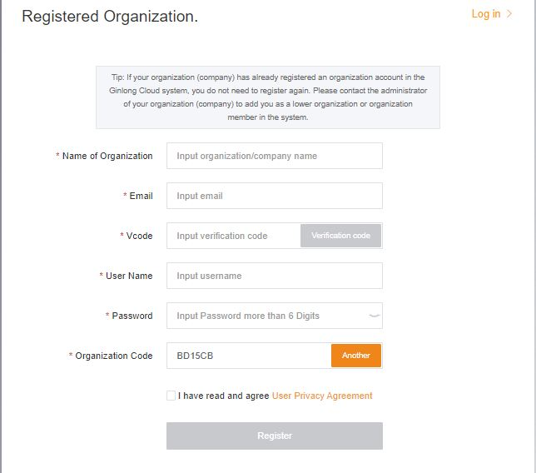
Registering an Owner: Enter in the homeowner email and then click “Verification code” to have a code sent to the address. Then enter that code into the box called “Vcode” where it says “Input verification code”. Enter a username and password and check the box by “I have read and agree User Privacy Agreement” and then click “Register”.
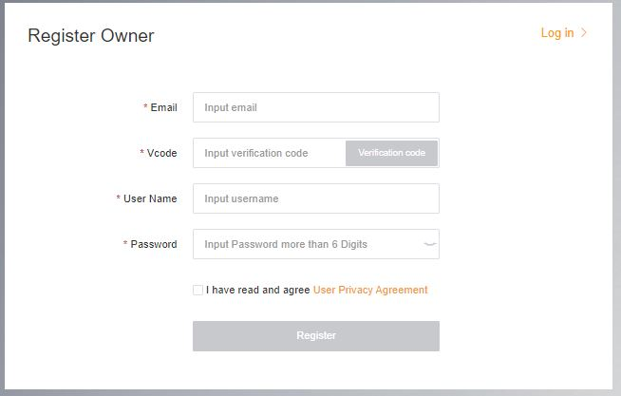
Homeowners can either register an Owner account or be added as a guest to a system created by an Organization Installers and technicians who wish to monitor the system should add the homeowner as a guest (see pages 6-7)
Migration: Anyone that was using the original Solis monitoring platform (Solis Home/Solis Professional) will need to migrate their systems over to the new platform. This is done by selecting “Data Migration” in the top right corner of the login page. The original login credentials will need to be used here. Enter the username/email address and password and then click on “Start Migration”, please note the migration takes a few hours to complete. The systems will show up on the new platform once the migration is complete.
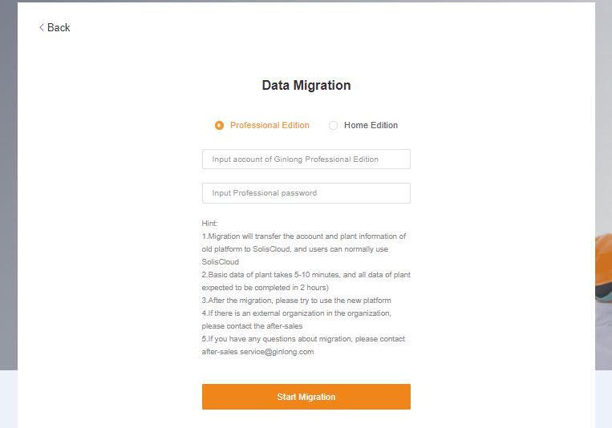
Once the registration/migration has been completed then you can log in to the new monitoring platform on the browser and the app. Go to the app store and search “SolisCloud” then download the app that comes up. At this point, all you should need to do is log in using your credentials. Check “Remember” if you do not want to put in your info every time.
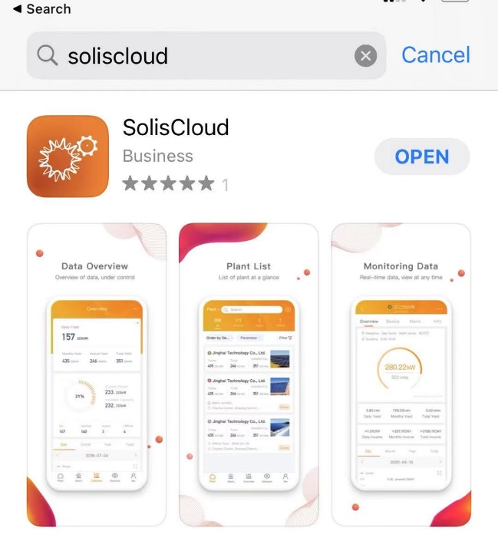
Part 2: Using the Platform – Monitoring and Alarms
The default page for the browser platform is the Plant Overview page. Here all of the plants that have been created by the user will be displayed. The plants can be sorted by name, yield, current power, installed capacity, and last to update. A green dot next to a system means the system is generating without any issues. A red dot means the system has an alarm and a grey dot means the system is not communicating.
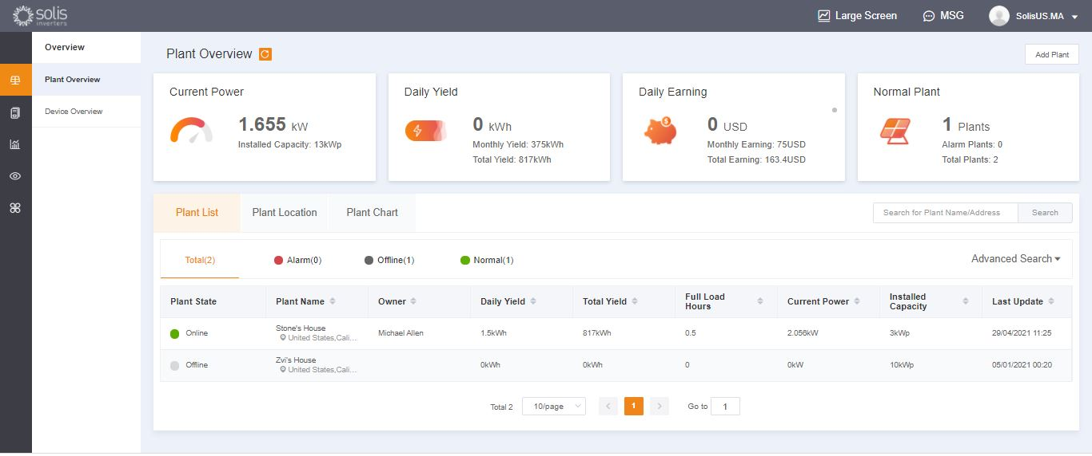
The Plant Location tab shows on a map where all of your registered systems are geographically
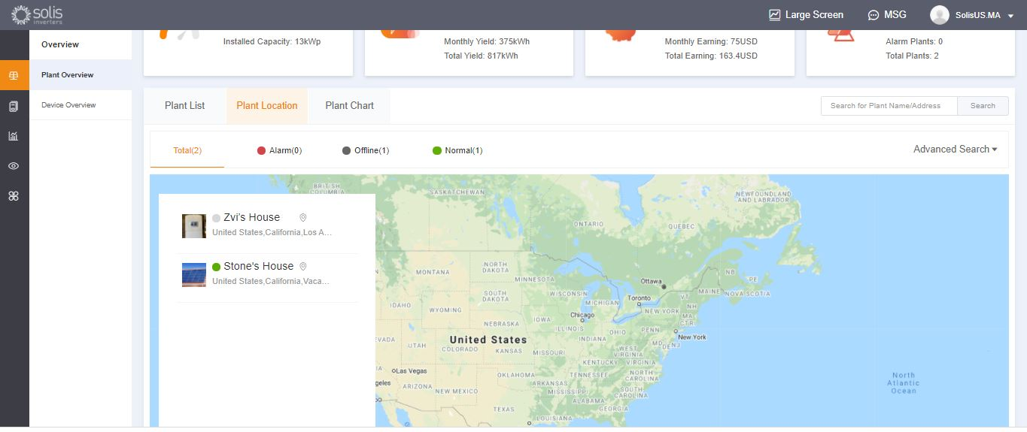
The Plant Chart tab shows daily yield for all registered plants – any day can be viewed
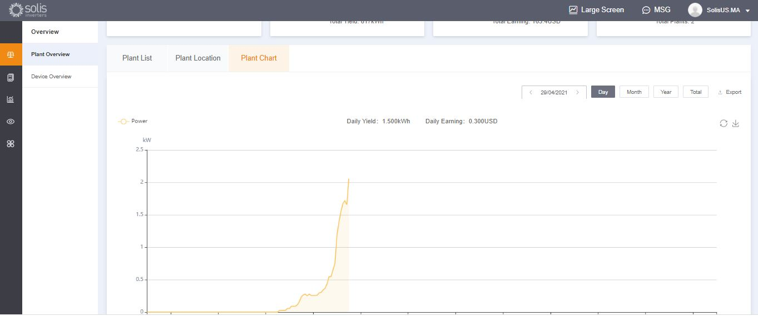
The Device Overview tab lets you view all of your registered devices by device type (Inverter, datalogger, etc.)
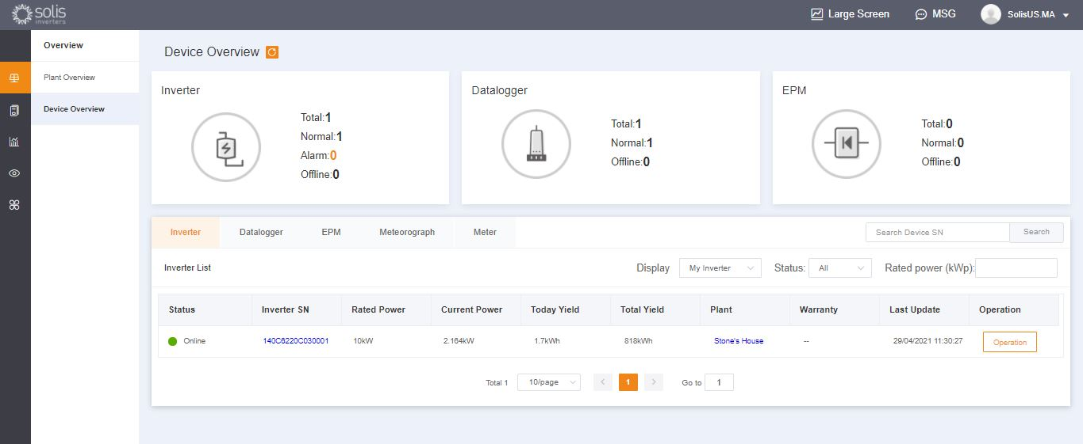
Click on the icon called “O&M” on the left side of the screen to view Alarm information. The alarms are broken down into three categories: Pending, Processed, and Restored. Pending alarms are current alarms that have not cleared. Restored alarms have been resolved by the system and are no longer showing up as a fault.
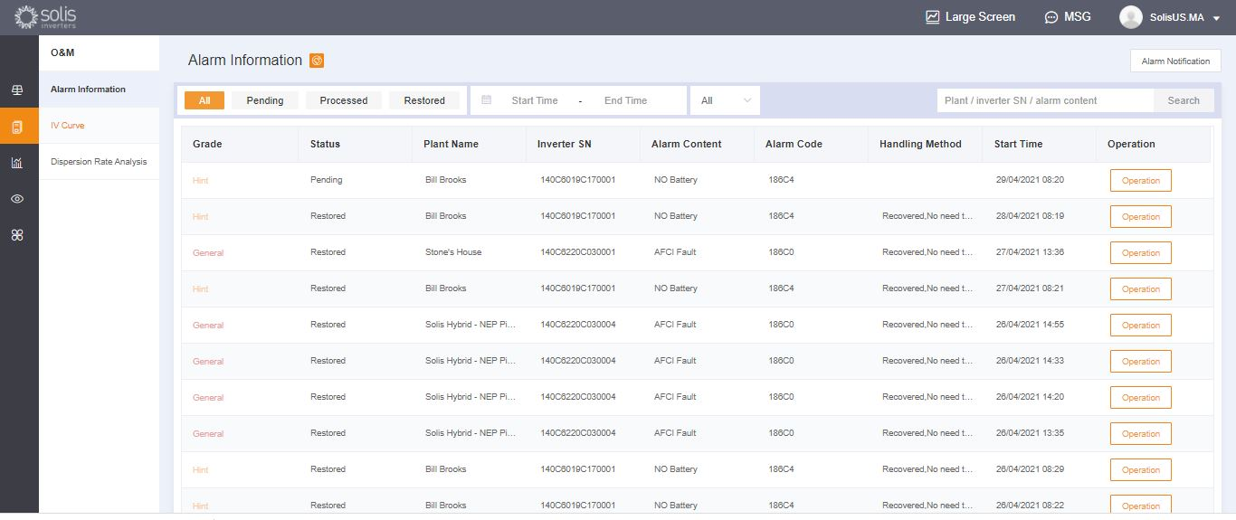
Pending alarms can be either ignored or deleted by mousing over “Operation” on the right side
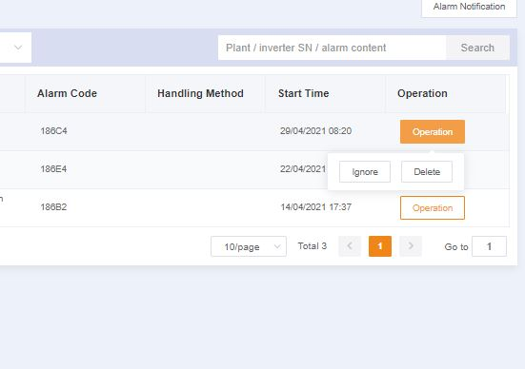
If pending alarm is not going away, please contact the service team by calling (866)438-8408 or by sending an email to: usservice@ginlong.com
Part 3: Commissioning Systems – Creating Plants and Adding Dataloggers
To add a new plant, start out on the Plant Overview page. Then click on “Add Plant” in the top right corner of the browser page.
Enter in all of the plant information and add the datalogger serial number. The Installed Capacity is the size of the system, not the inverter. Earnings per kWH should be the rate at which the utility charges for power. Finally, click “create Plant” to finish. The plant will now show up under the plant list but please allow the system half an hour to display data. Guests may be added here as well.
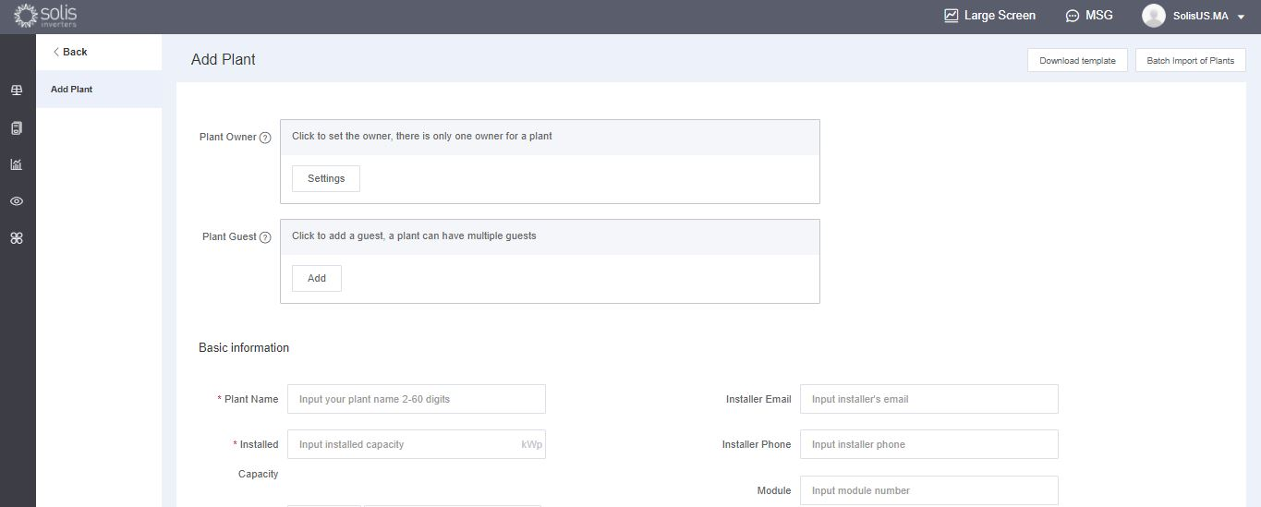
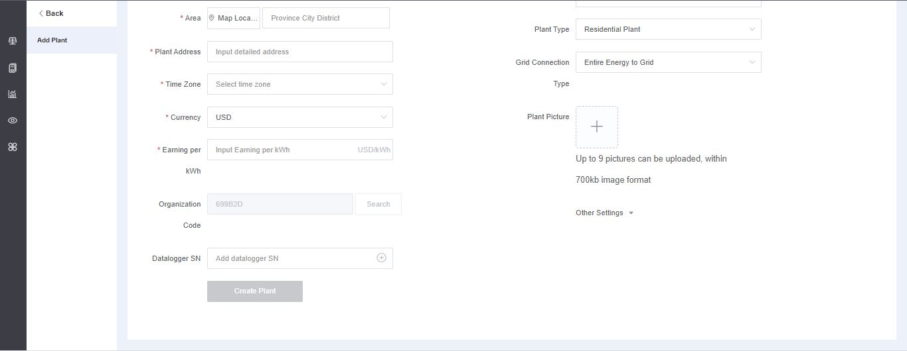
On the app tap the plus (+) icon in the top right corner of the screen and then tap “Add Plant”. Enter in the plant information keeping in mind that Installed Capacity is the size of the system, not the inverter. Earnings per kWH is the rate at which the utility charges for power. Guests can also be added here. Dataloggers can be scanned or added manually by entering in the serial number. Once the logger is scanned it will be added to the system.
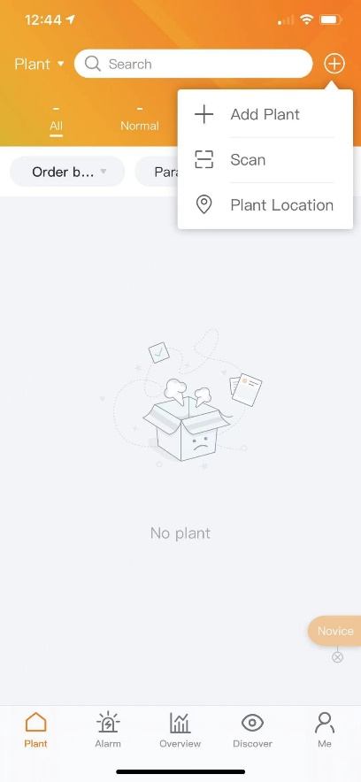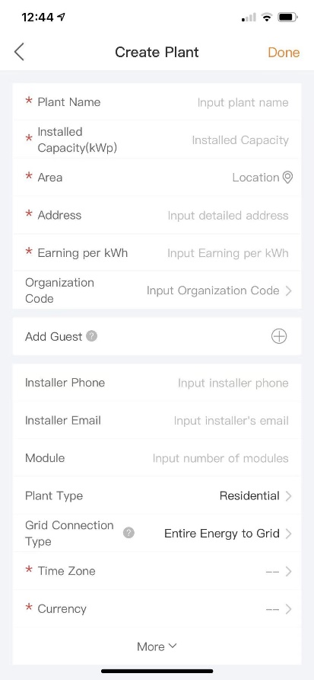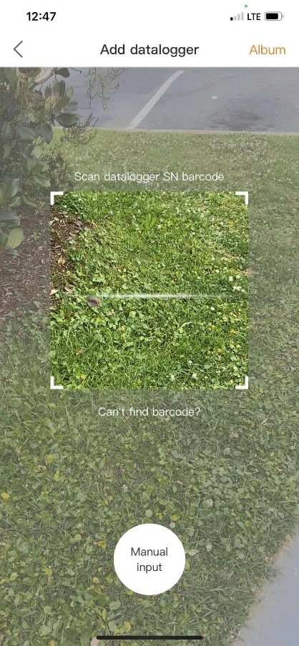
If you are scanning the loggers then be sure to scan the bar code on the logger itself and not the one on the inverter’s spec label, see examples of the logger bar codes below:
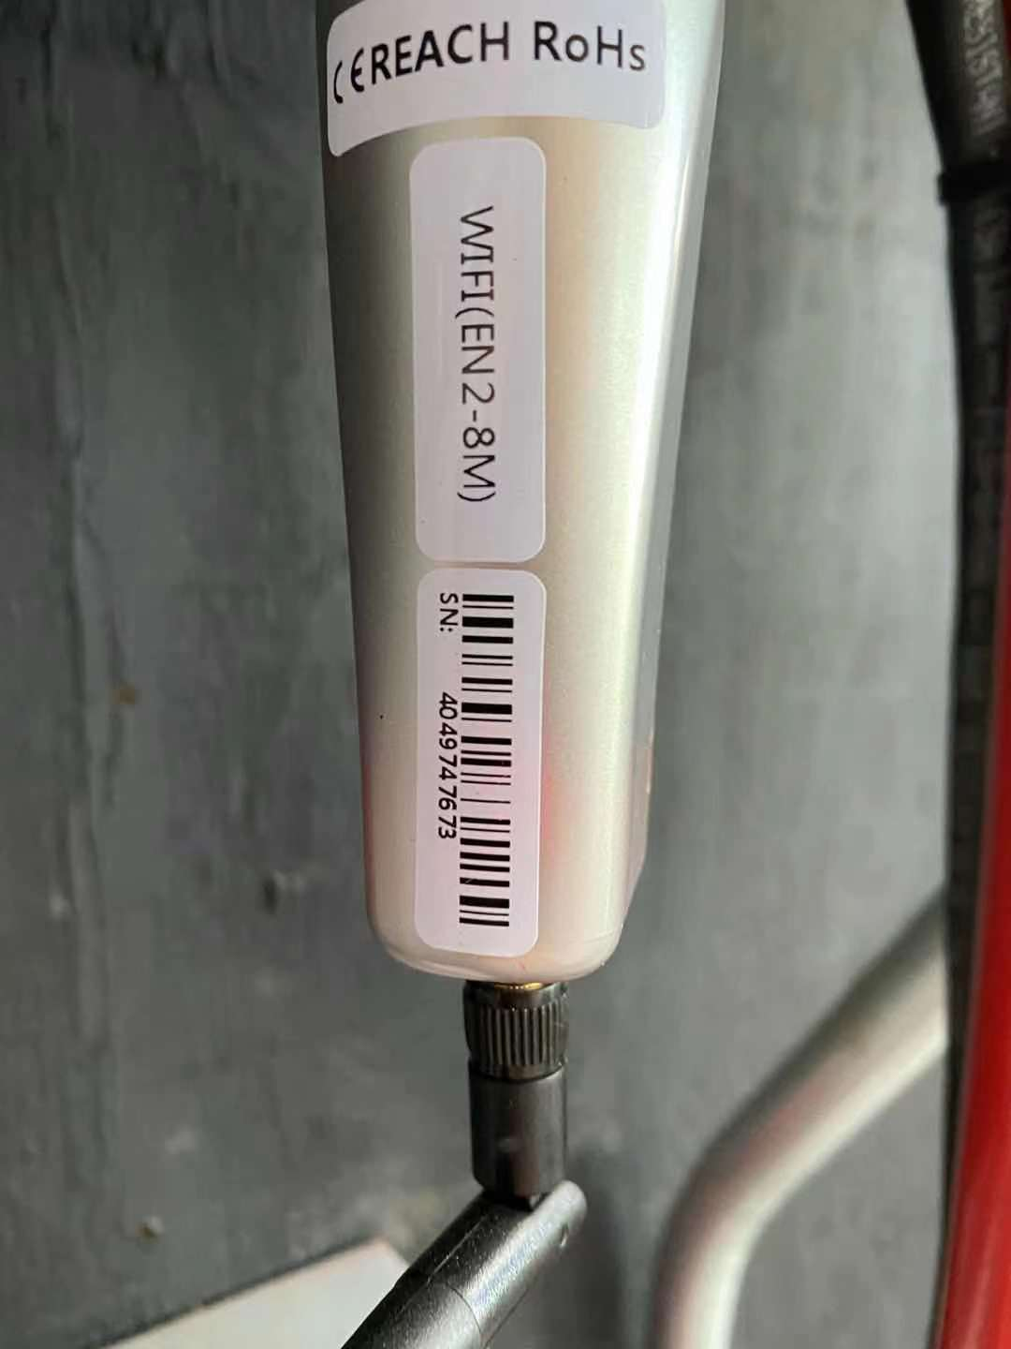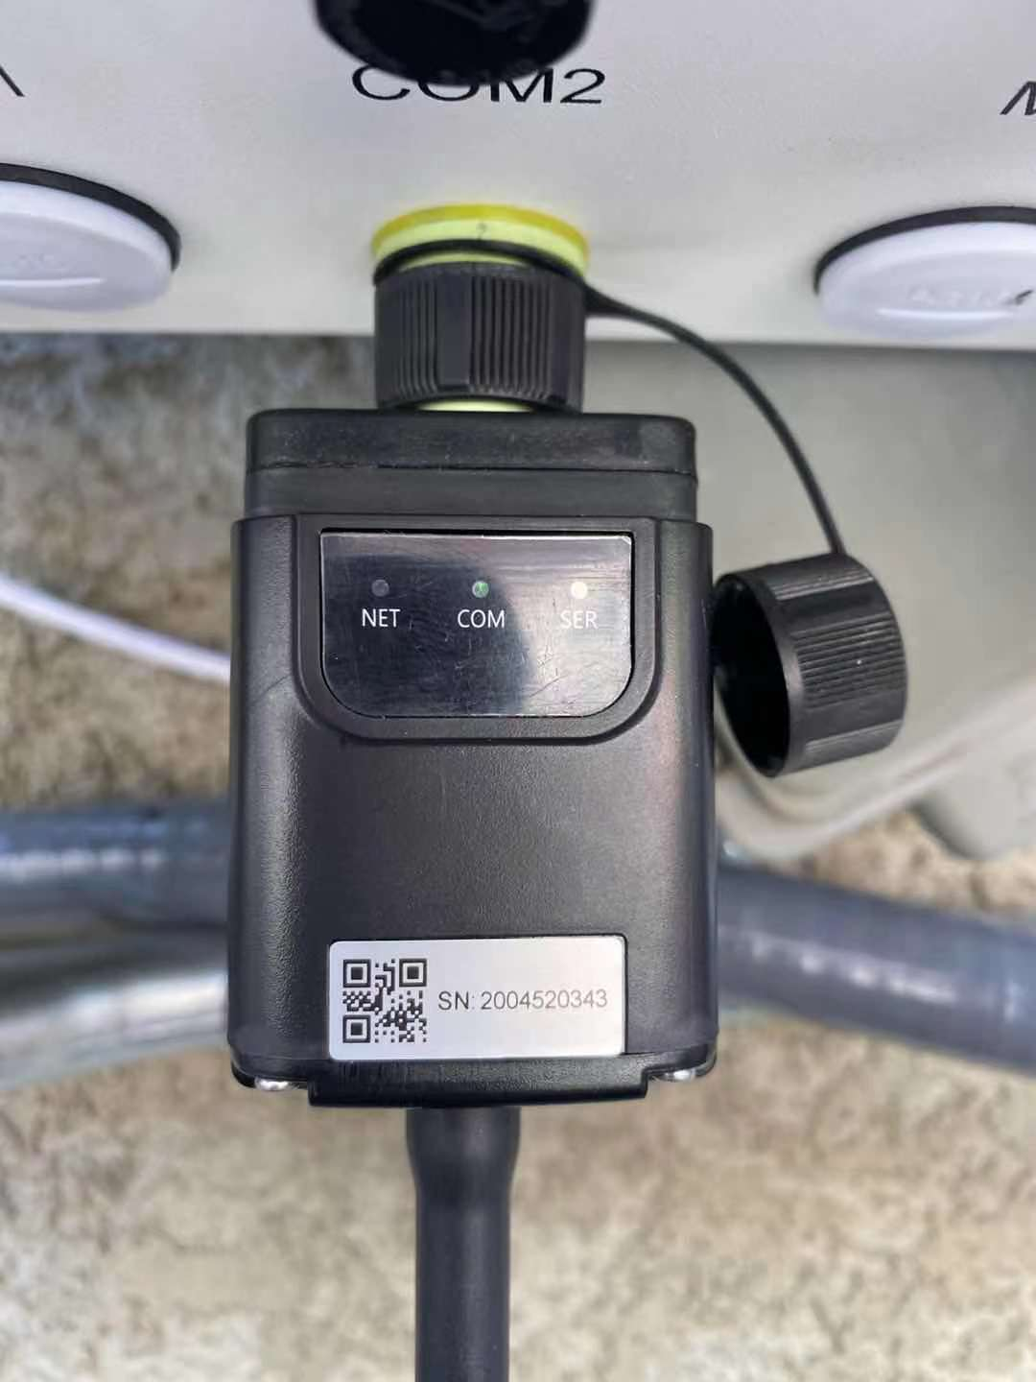
Part 4: Organization and Device Management
To add additional members to your organization, click the icon called “Service” on the left side of the page
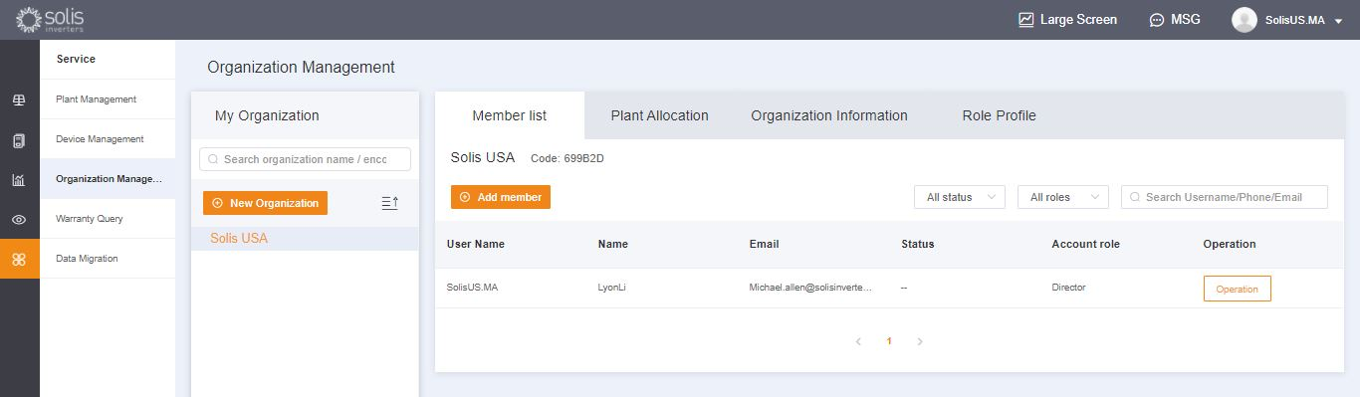
Click “Add member” and then enter in the information of the user that you wish to add. This feature is designed for individual installers and technicians to be added to an installation/O&M organization.
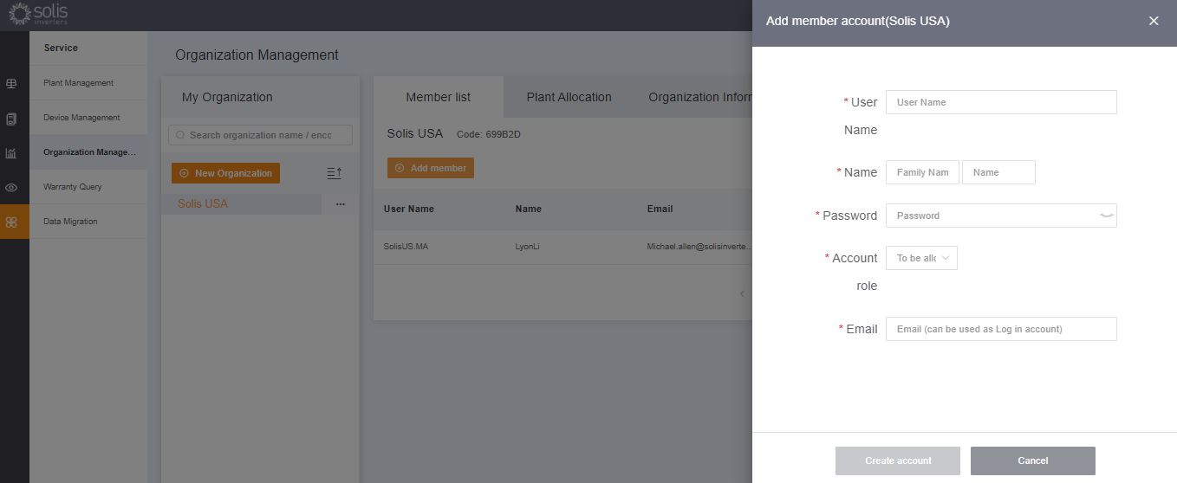
The new user will receive an email with a link to SolisCloud where they can then log in and add plants of their own.
Alternatively, a guest can be added by first selecting a plant and then clicking “Modify Information”
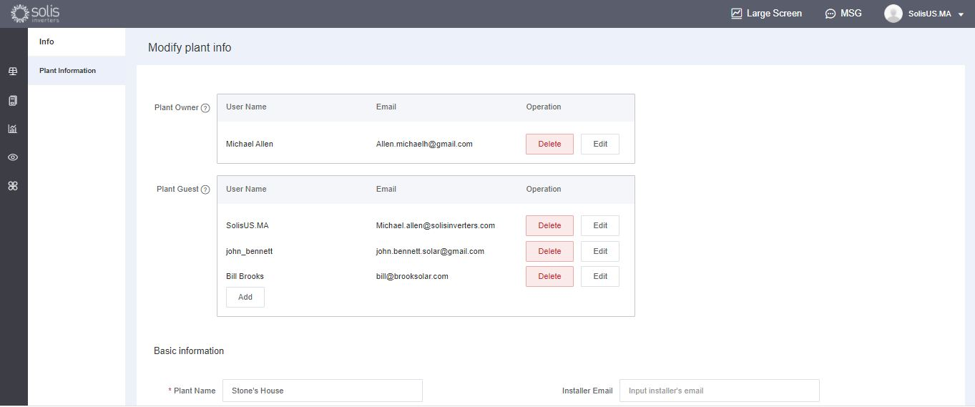
Enter in the email address of the guest. If they have registered already, then nothing else will need to be done.
If they have not registered before, then you will need to enter in the name of the guest and then click “Register and Associate”. A message will be displayed towards the top of the screen that says “Guest registered and associated successfully”
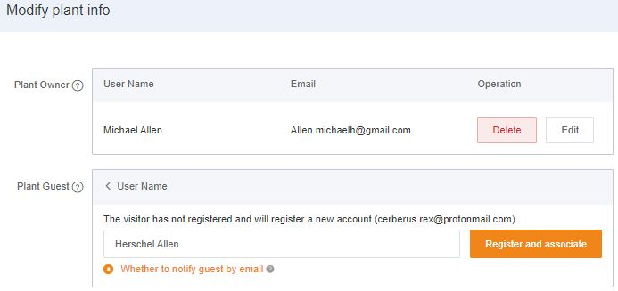
The guest will receive an email from SolisCloud saying their account is registered. They will be given a temporary password of 123456. The guest will be able to log in to both the SolisCloud app and the browser page using their email and the temporary password. It is recommended that they change their password after logging in for the first time.
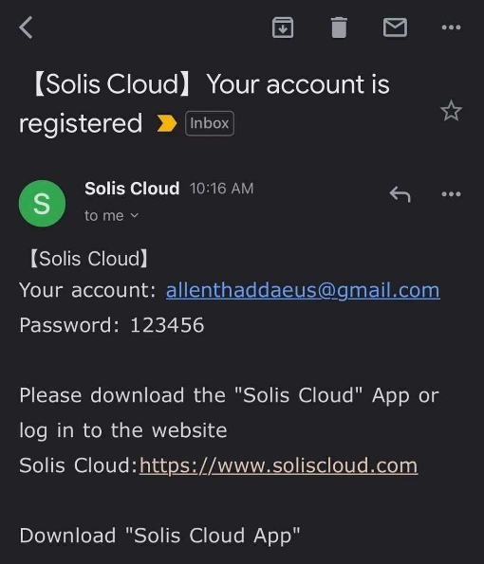
When the guest logs in to the new platform, they will need to click “Advanced Search”, then click “All” under “Plant Display”, and then click the orange “OK” in order to view the systems to which they have been added as a guest.
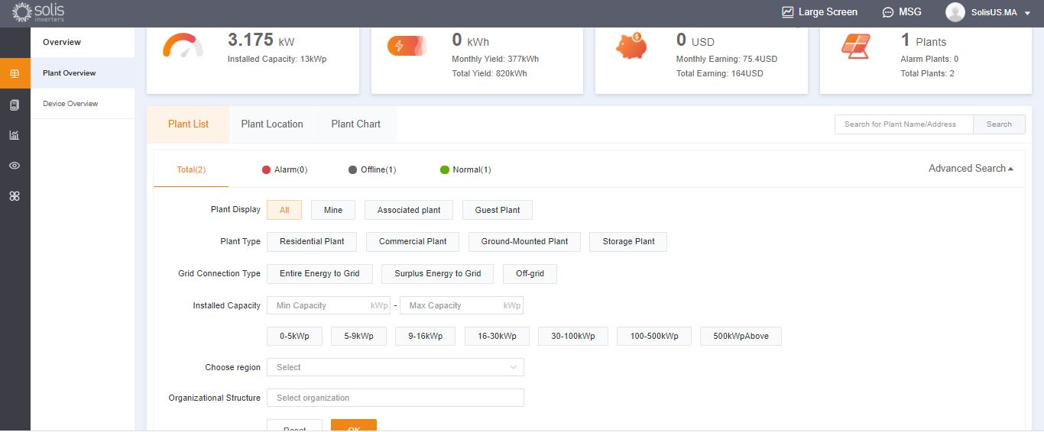
To enable or disable Alarm Notification emails and push messages, click on the “O&M” icon and then click “Alarm Notification” in the top right corner of the page.
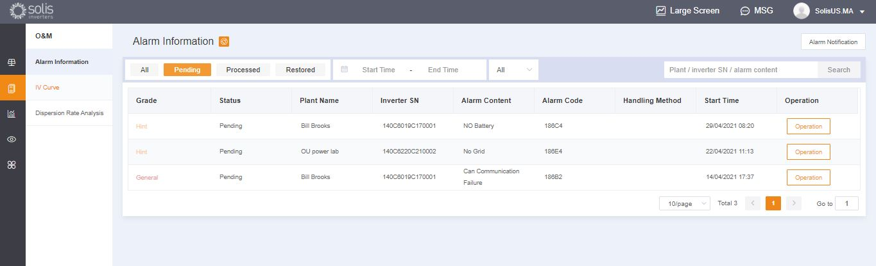
Push notifications will be displayed by your mobile phone. If you wish to receive push notifications then make sure the “Push Notification” slider is set to “Opened” with “Emergency Alarm” all three alarm types turned on. Email notifications will be sent to the email address of the registered user. The address of who will receive the email notifications can be manually changed here, be sure that the “Email Message” slider is set to “Opened”.
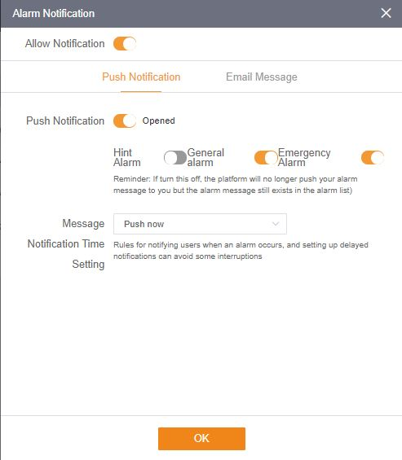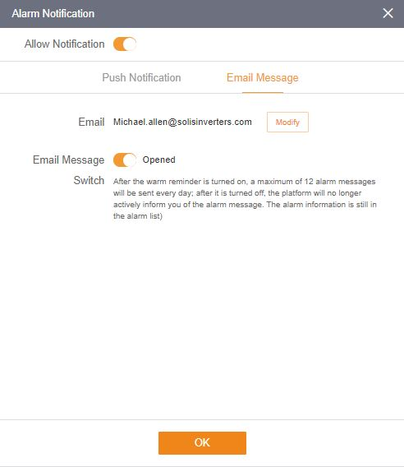
If an inverter needs to be removed from a plant, select the plant and then click “Device” on the left side of the page. Mouse over “Operation” on the right side of the page and then click “Delete” to remove the inverter from this site. Now a new inverter can be added to this site.
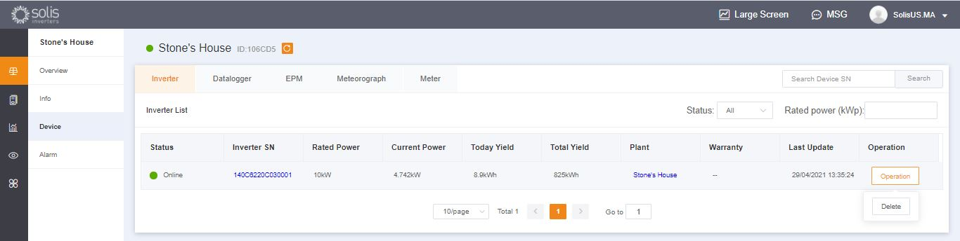
Dataloggers can also be replaced this way. Select “Datalogger” and then delete the logger in order to add a new one. This process unbinds the datalogger from the system allowing the logger to be installed on a different system and for the original system to have a new datalogger added.

